**Operation System HW1 b03705002林軒逸**

Code for Problem 1:

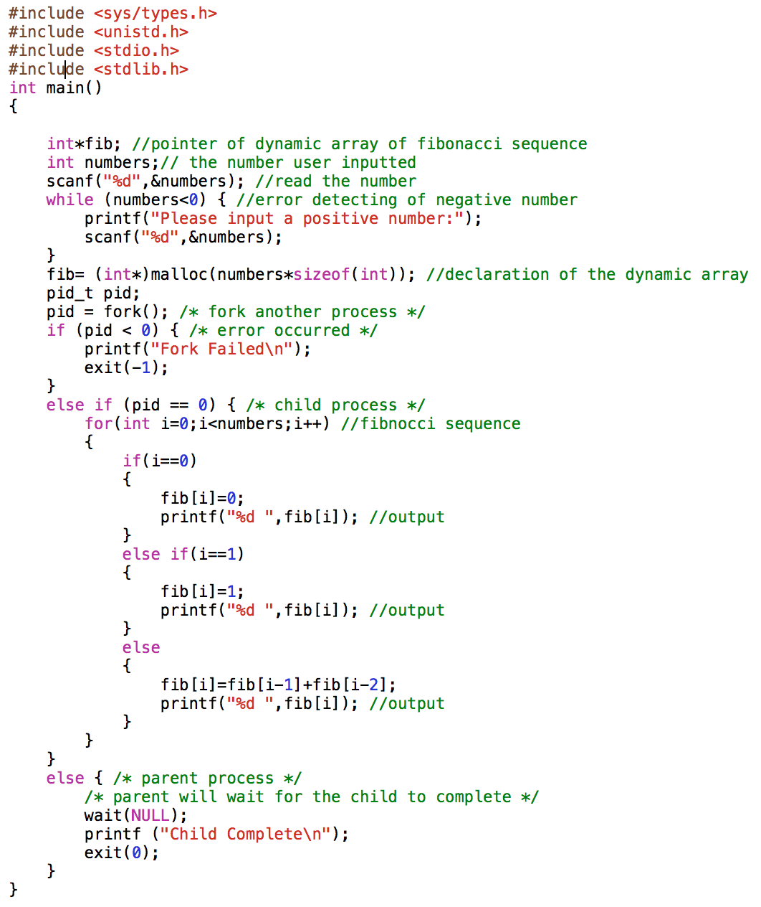

Explain for Problem 1:

First, I create a dynamic array call *fib* to create space for storing the Fibonacci sequence with length *numbers*.

*numbers is for storing the number the user entered, which is the length of fib.*

After that, we use the function *fork()* to create process. In the child process, we create the Fibonacci sequence and print all the required values out, and exit at the parent process.

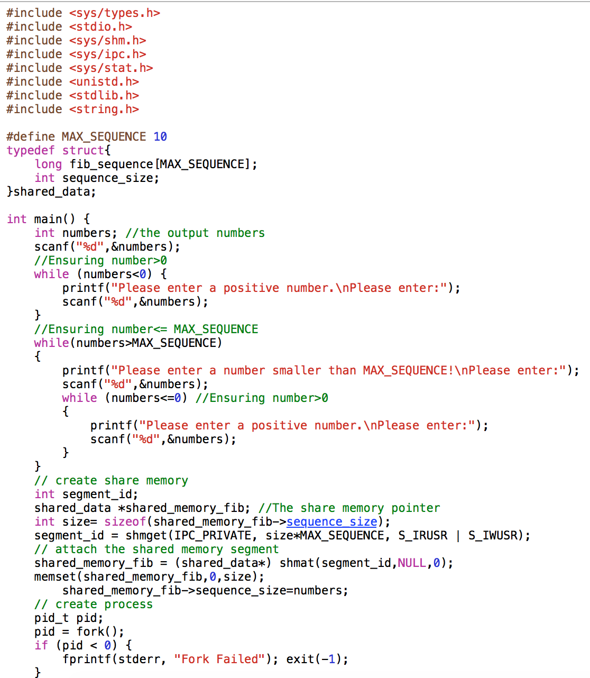Code for Problem 2:

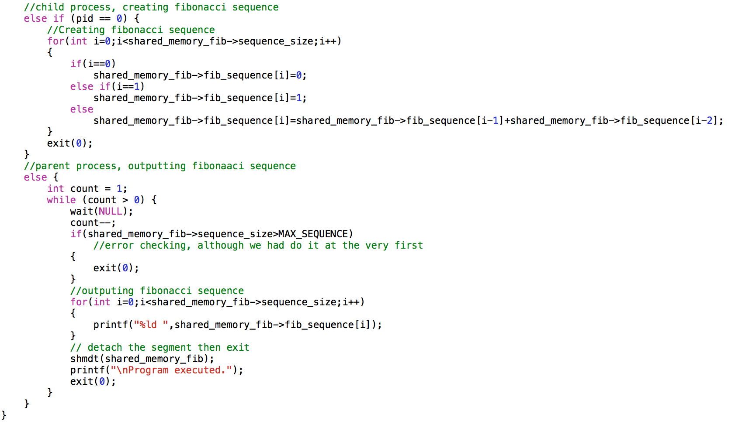

Explain of Problem 2:

First, we use the structure that the problem described, and create a pointer calls *shared_memory_fib* to do all the process.

Second, we check whether the input number is less or equal to 0 or bigger than MAX_SEQUENCE, we will ask the user to re-input a valid number.

After that, we create share memory by using *shared_memory_fib* and some functions, and then use *fork()* to create processes.

In child function, we calculate the Fibonacci sequence with length *sequence_size*, and in parent function, we output the Fibonacci sequence, and detach with shared memory, and then exit the program.

That’s all for my HW1, thanks for reading!